1.
a.Candidate key: A candidate key is a set of one or more attributes that can uniquely identify a tuple (row) in a relation (table). It has the potential to be chosen as the primary key.
b.Composite key: A composite key is a candidate key that consists of two or more attributes. These attributes together uniquely identify a tuple in a relation.
c.Foreign key: A foreign key is an attribute or a set of attributes in one relation that refers to the primary key of another relation. It is used to establish a relationship between two tables.
d.Functional dependency: Functional dependency is a relationship between two sets of attributes in a relation. If for every valid instance of an attribute set A, there is exactly one valid instance of an attribute set B, then B is said to be functionally dependent on A, denoted as A→B.
2.
The three integrity rules/constraints in the relational model are:
Entity Integrity: The primary key of a relation must uniquely identify each tuple and must not contain null values.
Referential Integrity: A foreign key in one relation must refer to an existing primary key in another relation or be null (if allowed).
Domain Integrity: Each attribute in a relation must have a defined domain (a set of valid values) and must adhere to the constraints defined for that domain.
3.
Table 1
- Entity Integrity: There are no violations as the primary keys (filmNo and directorNo) seem to be unique and not null.
- Referential Integrity: There is a relationship between the 'filmNo' in the 'Film' table and the 'directorNo' in the 'Director' table. As long as the 'directorNo' values in the 'Film' table match existing 'directorNo' values in the 'Director' table, referential integrity is maintained. In this case, it seems to be okay as the director numbers appear to be valid.
Table 2:
- Entity Integrity: The primary keys are not clearly defined in this example as presented. But if we assume Supplier and PartNo together form a primary key (as it seems to be a many-to-many relationship between Supplier and Part), then there is a violation as we have multiple rows with the same Supplier and PartNo combinations (e.g., JKC 1234 appears multiple times).
- Referential Integrity: There are no foreign keys defined in this simple example as presented, so no referential integrity issues can be identified from the given data.
Table 3:
- Entity Integrity: There are no clear primary keys defined in this example as presented. But if we assume 'Song' is the primary key, then there is a violation as we have a row with an empty 'Artist' value for 'A Kind of Magic'.
- Referential Integrity: There are no foreign keys defined in this simple example as presented, so no referential integrity issues can be identified from the given data.
4.
- a. Insertion Anomaly: When inserting a new project, we need to repeat the project details (ProjectTitle, ProjectManager, ProjectBudget) for each employee who will work on it. This is a waste of storage space and can lead to data inconsistency if the project details are not entered correctly for all employees.
- b. Deletion Anomaly: If project 'PrC10' is deleted, all the information about the employees who worked on that project will also be deleted. This may not be desirable as we may want to keep the employee information even if the project is completed or cancelled.
- c. Modification Anomaly: If 'J Kirk' is moved from department 'L004' to department 'L009', we need to update the department information in multiple rows where 'J Kirk' is involved. This can be time-consuming and error-prone.
- d. 1NF: To achieve 1NF, we need to eliminate repeating groups. In this case, we can split the table into two tables: Project (ProjectCode, ProjectTitle, ProjectManager, ProjectBudget) and ProjectEmployee (ProjectCode, EmployeeNo, EmployeeName, DepartmentNo, DepartmentName, HourlyRate). Each table now has atomic values in each column and no repeating groups.
- e. 2NF: In the ProjectEmployee table, the non-key attributes (EmployeeName, DepartmentNo, DepartmentName, HourlyRate) are functionally dependent on the composite key (ProjectCode, EmployeeNo). However, EmployeeName is also functionally dependent on EmployeeNo alone. To achieve 2NF, we can split the ProjectEmployee table further into two tables: Employee (EmployeeNo, EmployeeName, DepartmentNo, DepartmentName, HourlyRate) and ProjectEmployeeLink (ProjectCode, EmployeeNo). Now, in the Employee table, all non-key attributes are functionally dependent on the primary key (EmployeeNo).
- f. 3NF: In the Employee table, DepartmentName is functionally dependent on DepartmentNo. To achieve 3NF, we can split the Employee table into two tables: Department (DepartmentNo, DepartmentName) and Employee (EmployeeNo, EmployeeName, DepartmentNo, HourlyRate). Now, all non-key attributes in each table are functionally dependent on the primary key and there are no transitive dependencies.
5.
- a. Anomalies:
- Insertion Anomaly: When inserting a new order, we need to repeat the customer information (Customer, Address) for each item in the order. This is a waste of storage space and can lead to data inconsistency if the customer information is not entered correctly for all items.
- Deletion Anomaly: If an order is deleted, all the information about the customer and the items in that order will also be deleted. This may not be desirable as we may want to keep the customer information even if an order is cancelled.
- Modification Anomaly: If a customer's address changes, we need to update the address in multiple rows where that customer's orders are listed. This can be time-consuming and error-prone.
- b. 1NF: We can split the table into two tables: Order (Order No., Acc.No., Customer, Address, Date) and OrderItem (Order No., Item, Qty., Price, Total Cost). Each table now has atomic values in each column and no repeating groups.
- c. 2NF: In the OrderItem table, the non-key attributes (Qty., Price, Total Cost) are functionally dependent on the composite key (Order No., Item). However, Price and Total Cost are also functionally dependent on Item alone. To achieve 2NF, we can split the OrderItem table further into two tables: Item (Item, Price) and OrderItemLink (Order No., Item, Qty., Total Cost). Now, in the Item table, all non-key attributes are functionally dependent on the primary key (Item).
- d. 3NF: In the OrderItemLink table, Total Cost is functionally dependent on Qty. and Price (Total Cost = Qty. * Price). To achieve 3NF, we can calculate Total Cost on the fly when needed and remove it from the OrderItemLink table. Now, all non-key attributes in each table are functionally dependent on the primary key and there are no transitive dependencies.
6.
- a.
- Patient: (PatientNo, Surname, FirstNname)
- Admission: (PatientNo, Admitted, Discharged, Ward)
- Doctor: (DoctorNo, Surname, FirstName, Ward)
- Ward: (Ward, WardName, DoctorNo -)
- b. Relations and Links:
- The 'Patient' table has a one-to-many relationship with the 'Admission' table. The foreign key in the 'Admission' table is 'PatientNo' which refers to the primary key 'PatientNo' in the 'Patient' table.
- The 'Doctor' table has a many-to-one relationship with the 'Ward' table. The foreign key in the 'Doctor' table is 'Ward' which refers to the primary key 'Ward' in the 'Ward' table.
-c.
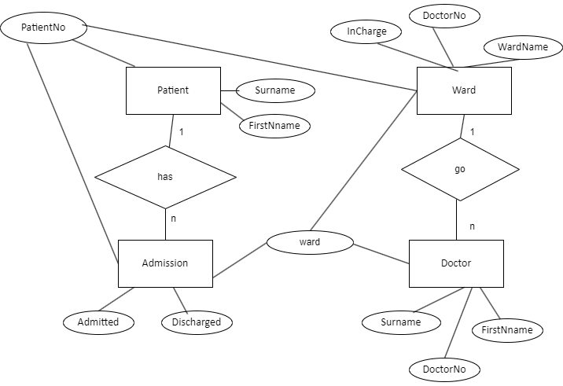
7.
- a. Table 1 Catering:
- Order No. → Account No., Customer, Address, Date
- Account No. → Customer, Address
- Customer → Address
- Item → Quantity, Item Price
- b. 1NF: We can split the table into two tables: Order (Order No., Account No., Customer, Address, Date) and OrderItem (Order No., Item, Quantity, Item Price). Each table now has atomic values in each column and no repeating groups.
- 2NF: In the OrderItem table, the non-key attributes (Quantity, Item Price) are functionally dependent on the primary key (Order No., Item). However, Item Price is also functionally dependent on Item alone. To achieve 2NF, we can split the OrderItem table further into two tables: Item (Item, Item Price) and OrderItemLink (Order No., Item, Quantity). Now, in the Item table, all non-key attributes are functionally dependent on the primary key (Item).
- 3NF: In the OrderItemLink table, there are no transitive dependencies. The tables are now in 3NF.
- a. Table 2 Student records:
- Student No → Name, Course, Course Duration
- Course → Course Duration, Module No, Module name, Lecturer
- Module No → Module name, Lecturer
- b. 1NF: We can split the table into two tables: Student (Student No, Name, Course, Course Duration) and CourseModule (Student No, Course, Module No, Module name, Lecturer). Each table now has atomic values in each column and no repeating groups.
- 2NF: In the CourseModule table, the non-key attributes (Module name, Lecturer) are functionally dependent on the composite key (Student No, Course, Module No). However, Module name and Lecturer are also functionally dependent on Module No alone. To achieve 2NF, we can split the CourseModule table further into two tables: Module (Module No, Module name, Lecturer) and CourseModuleLink (Student No, Course, Module No). Now, in the Module table, all non-key attributes are functionally dependent on the primary key (Module No).
- 3NF: In the CourseModuleLink table, there are no transitive dependencies. The tables are now in 3NF.
8.
- a. Functional Dependencies:
- Report ID, Reporting Period → Branch Code, Branch Name, Supervisor ID, Supervisor Name
- Branch Code → Branch Name, Supervisor ID, Supervisor Name
- Car Plate Nr → Car Type
- Bill Nr → Bill Date
- Penalty → Final Bill
- b. 1NF: We can split the table into the following tables:
- Report (Report ID, Reporting Period, Branch Code, Branch Name, Supervisor ID, Supervisor Name)
- Car (Car Plate Nr, Car Type)
- Bill (Bill Nr, Bill Date)
- Penalty (Penalty, Final Bill)
- 2NF: In the Report table, Branch Name, Supervisor ID, and Supervisor Name are functionally dependent on Branch Code. To achieve 2NF, we can split the Report table further into two tables: Branch (Branch Code, Branch Name, Supervisor ID, Supervisor Name) and ReportLink (Report ID, Reporting Period, Branch Code). Now, in the Branch table, all non-key attributes are functionally dependent on the primary key (Branch Code).
- 3NF: In the Branch table, Supervisor Name is functionally dependent on Supervisor ID. To achieve 3NF, we can split the Branch table into two tables: Supervisor (Supervisor ID, Supervisor Name) and Branch (Branch Code, Branch Name, Supervisor ID). Now, all non-key attributes in each table are functionally dependent on the primary key and there are no transitive dependencies.

9.
- a. Functional Dependencies:
- Boat ID → Type of marine equipment, Servicing time, List of tasks
- Engineer ID → Name of engineer
- Task ID → Service description
- b.
- Boat (Boat ID, Type of marine equipment, Servicing time)
- Engineer (Engineer ID, Name of engineer)
- Task (Task ID, Service description)
- BoatTask (Boat ID, Task ID, Servicing time)
- EngineerTask (Engineer ID, Task ID, Man-hours)
- c.
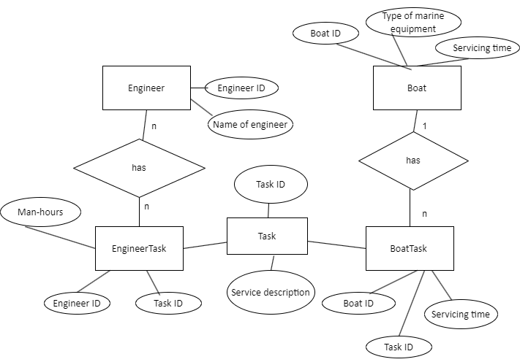
- d. Populate: For example, in the 'Boat' table, we could have (1, 'Sailboat', 5 hours), in the 'Engineer' table, we could have (1, 'John'), in the 'Task' table, we could have (1, 'Software upgrade'), in the 'BoatTask' table, we could have (1, 1, 3 hours), and in the 'EngineerTask' table, we could have (1, 1, 2 hours).
- e. 1NF: The tables are already in 1NF as they have atomic values in each column.
- 2NF: In the BoatTask table, Servicing time is functionally dependent on Boat ID and Task ID. There are no issues with other tables for 2NF.
- 3NF: In the BoatTask table, there are no transitive dependencies. The tables are now in 3NF.

